***Course Project: Phase II(Final Submission)***

***Submitted by Group 06***

***Mahima Chowdary Kodali – L30065273***

***Venkata Gopi Mandalapu – L30064298***

# Analysis and Design of Software Architecture for the Next Generation of IOT Technology

# Introduction

The internet of things IoT is been observed as the ambiguous concept. The term IoT is been obtained as the buzzword and it basically applied to elaborate the systems which connects the physical world with the enhancement of the digital world output. Basically, this is been gained through the real-world physical objects, which was been disconnected from the different network connections, connectivity of the digital world been enhanced through variety of methods. In accordance with the advancements, the sectors of small processing unit tend to extend with various sensors which is been measured through the attributes of the real-world objects. Application of the IoT has been varied from merging the human body through help of the wearable sensor towards the smart cities and many solutions producing with help of the many sensors’ initiation throughout the world enhancement.

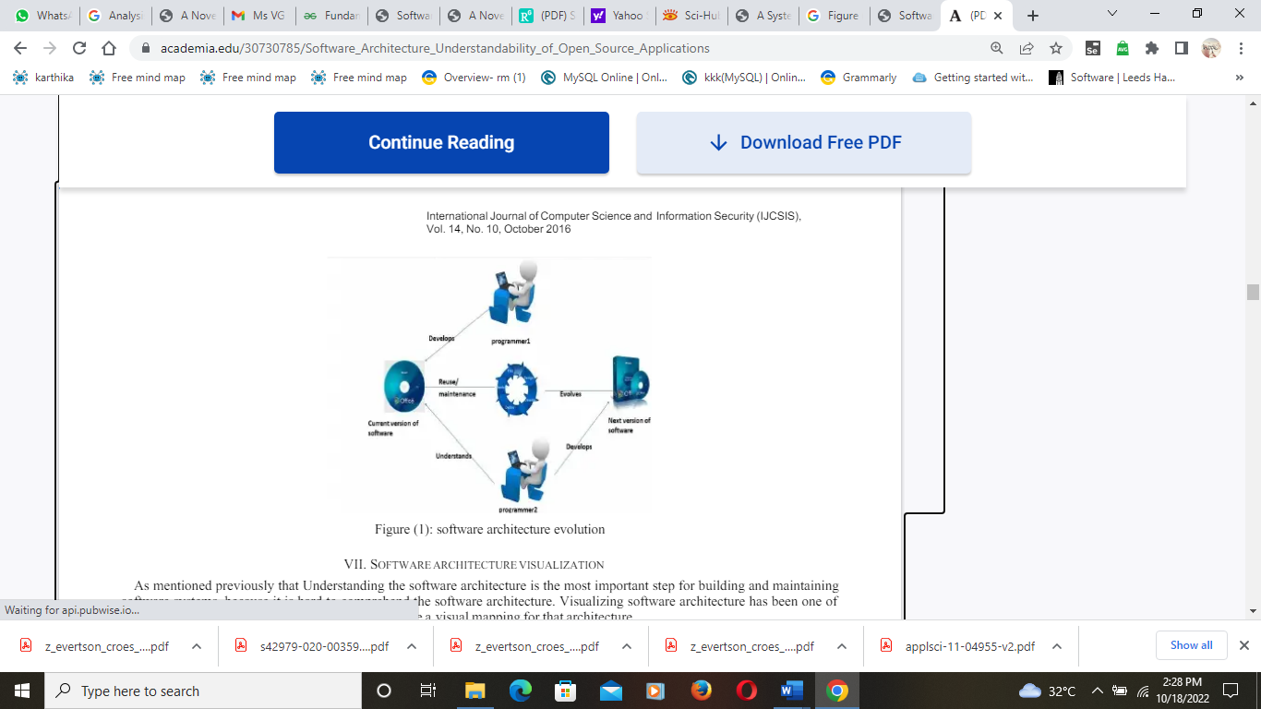

**Figure 1 - Evolution of software architecture** [1]

As initiated on the above figure 1 the evolution of the software architecture is been well initiated which indicates the best solution for many issues. On the proposed report the enhancement of the software architecture will be undertaken for the future development of IoT. Basically, evolvement of the software architecture seems to produce the best solutions and results. And the software architecture is the defined to be the artefact, which tends to show the straightforward and prediction methods on the complexity software systems. And the proposed research would be analyzing with the Microsoft architecture for the IoT development. In which the microservice architecture would be supporting to enhance the complicated system application, and it conveys the system application in the split manner for system application decomposing. The microservice architecture seems to be the heart of the IoT since it is the independent services. the microservice related high system will be related with the platforms which is to empower the information related to the dissemination for direction and to prepare the IoT devices in the central cloud and edges.

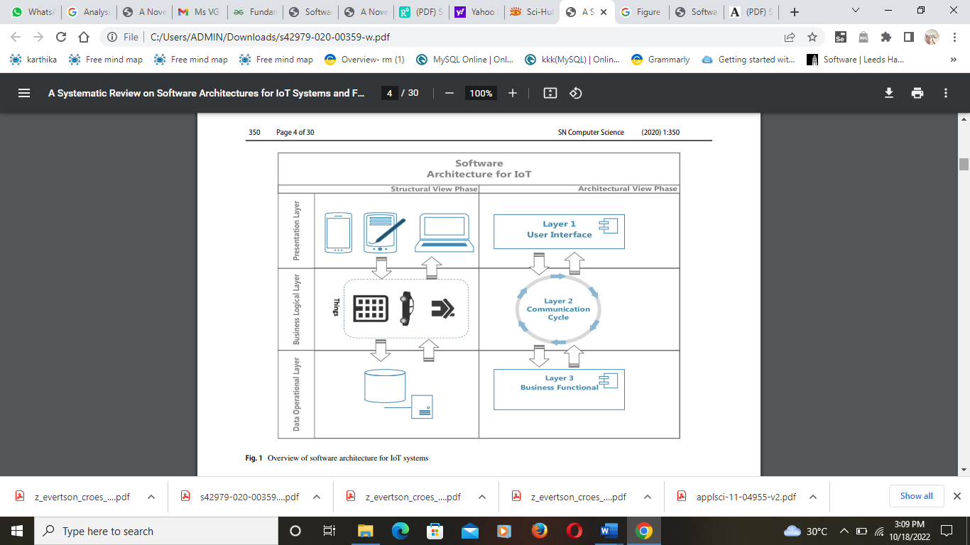

**Overview on the software structure for IoT system** [2]

The figure 2 initiates with the software structure for the IoT system development. Basically, the initiate figure consists of various styles and layers which tends to initiate the user interface, communication cycles and business-based function system. the presentation layer, business layer and data operational layers seems to progress the further work with best solution implementation. This structure seems to indicate the overall view and process of the software structure for the IoT growth and development. It also indicates the abstract level of the architecture model and it results the complexity of the IoT system initiation with configurations. Hence, the proposed report would be designed and analyzed with the software architecture systems for the future development of IoT and further some of the present issues and problems would be initiated through the enhancement of the development of proposals.

# Problems

In present, there are varieties of problems enhanced within the IoT development. Some of the problems would be analyzed and initiated within this research proposals for the producing of the effective solutions with the present study. Most common issue that the IoT seems to follow is the security-based issues for which the data regarding the management of the data are not properly managed and maintained effectively. The threats and attacks seem to be emerged largely in the enhancement of the IoT development which could not obviously induce the best resolutions and findings. And the clarity lagging is another based issue formed on the present IoT technology which is not obviously observed to be the best on any access. The IoT device safety and the providence of the data progressing for many organizations is not effectively managed. Hence, some of the problems and these issues would be making issues on the field of any organization sector, further in means of avoiding such issues the proposed work is enhanced with the development of software system architecture with latest and full privacy-based system approaches. In this report the microservice approaches architecture is been adopted in initiating towards the development of IoT systems.

# Literature reviews

[3] develops the software architecture styles for the internet of things with the effective techniques and approaches. This paper tends to initiate the list of important IoT based factors with help of the styles of software architecture that would be applied on the future IoT projects and some of the effective reference architecture is also initiated within this paper. And as the result the author seems to indicate the internet of things must be applied on the software architecture schemes. Further, the various classes development to be subsets with the IoT enhancement with various styles and patterns. Major aim of this paper was to list every IoT solution towards the physical entity and this is been measures with the alternative attribute’s findings. The software architectural styles been labelled and composited with the different forms of initiation in the development of the best solutions and accessing progresses. The author has exposed the REST architectural styles in means of initiating the common topology for the client-server styles with the expectations of the components access through same styles and schemes. And the trade-off performance was accessed with the enhancement of the initiation.

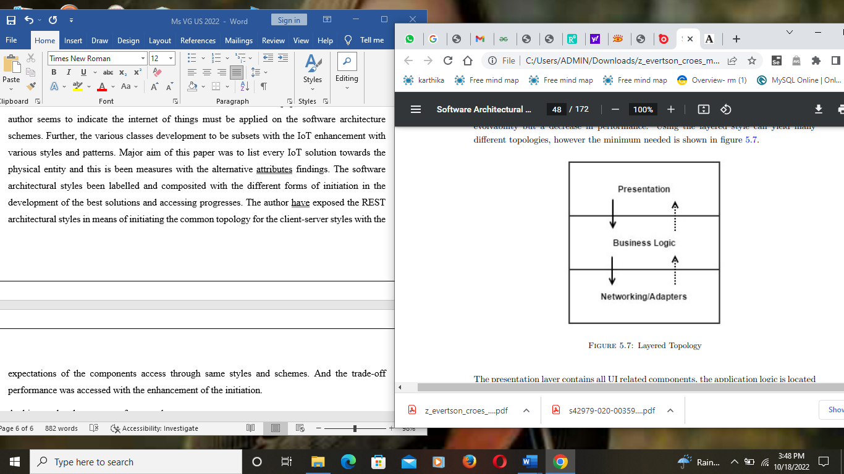

**Layered topology structure** [3]

As initiated on the above figure the development of the layered topology was implemented through the author for the development of the IoT. This layer was tending to contain various forms such as the presentation layer were observing through the UI based components and the application logic is been initiated with the middle layer for the logic to move on to connection of the devices with the network-based layer accessing. The author has also proposed the microkernel-based style which tends to initiate the different components through the less functionality access that are needed for the IoT development application which is the microkernel, the lagging on the security forms been missed out.

[4] exposes the useful novel on creating the software architecture solution on aiming on the large-term IoT device support for the security access. The author was aimed on producing the best solution for upgrading the present device models towards the industry 4.0 smart device, through the intend of the management of large compatibility. And the novel was also seemed to satisfy the smart devices characteristics with high enhancement. The author has predicted or analyzed the present IoT architecture and proposed the new structure for the access of long-term security and usability of the IoT devices. In accordance with the management of long-term security management, author have rejected the device possibilities for the configuration on the external system with the dedicated protocols. The effective security concepts been undertaken over this literature for the analyzing and modification of the further systems. In means of raising the compatibility through previous device models, the author proposed the method for data collection from the sensory with help of the multithreaded microcontroller component. Further, the software components were also proposed within the paper in order to ensure the factory of programming, cloud maintenance and data analysis management. According to accessed experiments, the algorithm was accessed for the accuracy raising with the temperature and flow sensor involvement.

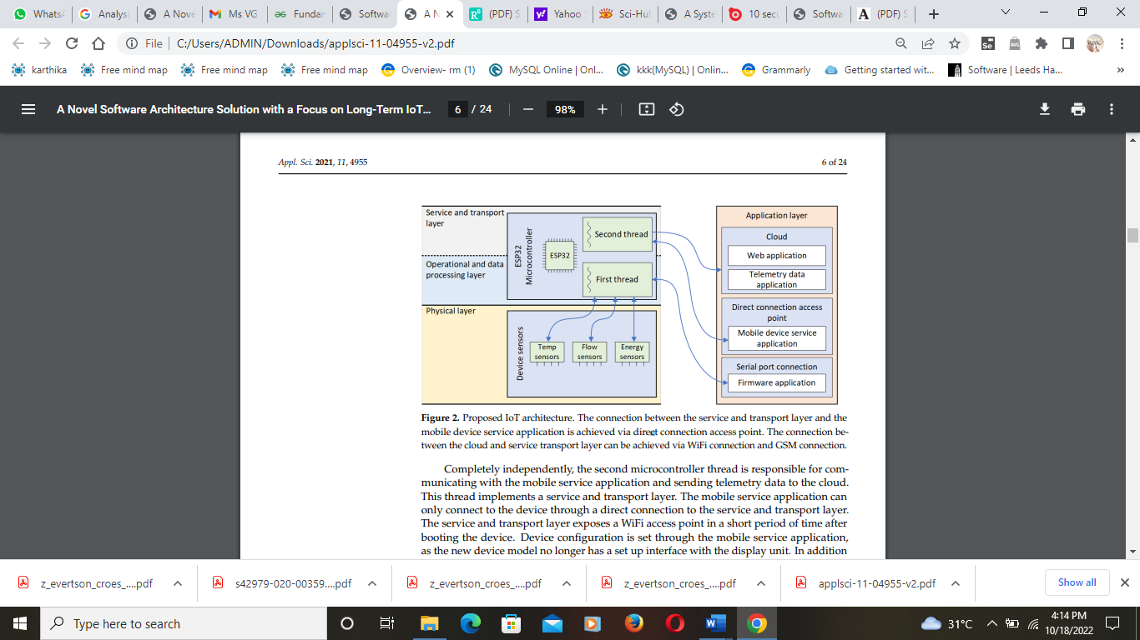

**IoT architecture** [4]

The above figure was proposed by the author with the development of latest IoT architecture which is connected with the service and transport layer with the mobile devices application and been achieved through the direct connections of the access points and accessing. And the connection enhanced is been tend to implement the cloud and service transport layer with the connections of network.

[5] initiates the software architecture and software designs on the various sectors and development of the progresses. The software architectural seems to be the strategic designs and it performs various activities with the concern accessing of the global requirements as well the solution been initiated with the programming paradigms, component-based systems, architectural styles and security system with the integration and regularities of the law-governed. In which, the functional design been elaborated with the tactical design, and been concerned through the local requirements with the access of solutions, design patterns, programming idioms and low-level initiation. And the author has initiated some of the software architecture patterns and designs with various design patterns. The serverless architecture is been proposed by the author for the effective development of the software designs and structure. Basically, proposed architecture seems to obtain with the major two parts such as the backend as a service, which is been called as the function as a service. As initiated by the author the serverless architecture seems to help many times taking care for the fixed bugs with the deployment of regular works. Author have initiated and proposed the microservice architecture which tends to initiate the different standards with the solving of the singular works with module communication. And the software design was enhanced with the methods of proposing the different structures and development. The author applies the opened closed principle, with the single responsibility principal schemes and development progresses.

[6] develops the survey on the internet of things with the software architecture. On which the IoT seems to be the effective concepts on day today life. It enables with the development of the objects, applications and services. The purpose of the IoT is to evaluate the connection type on any objects. The paper was indicated with the survey on IoT which effectively meets up the software requirements. Basically, the author has proposed the layered architecture for the IoT enhancement with five different layers through the management, security, capability and enhancement. As the review analyzed, it was found that the management of the IoT would be possible in accessing the points of the results and solution.

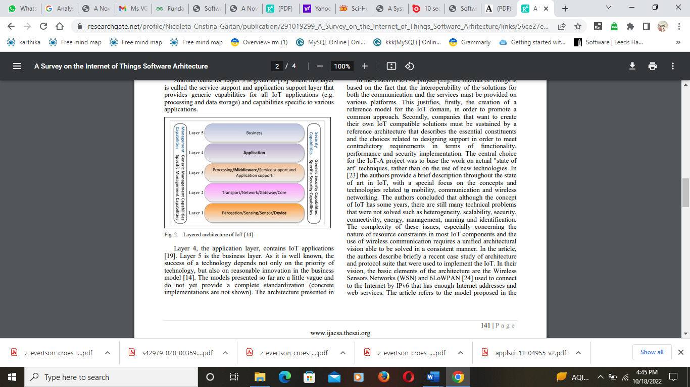

**IoT layered architecture** [6]

The above figure was initiated by the author for the development of best results on the IoT application, in regarding the security forming the above layered architecture would be helpful for the development of producing the best results. The implemented different layers seem to produce the benefits of various forms and access points.

…. Author proposes the architectural patterns for the development of microservices and all over systematic mapping study is enhanced within the research. The paper have aimed on diving various microservices architectural styles pattern and some of the principles which enhanced with the elaboration. And the author have ini

**Literature gaps**

Hence, different literatures were analyzed and initiated on this proposed report which shows various techniques, methods and approaches as well. Further, development of the software architecture could be managed and maintained with various forms but some of the literatures were been highly tend to make some of the gaps. Some of the issues were extended within the subjects and approaches which to be mitigated with the further development of solutions. In which the author also initiated two different key contributions. And in starting many of the microservices architecture patterns were accessed and initiated with the particular forms of the study. And in other form of the work the author presents the catalogue on the basic template format which consists of the benefits, laggings and some of the accessed lessons from the different patterns. And the author concludes that various architecture patterns seem to show the migration, storage and deployment settings for the accessed principles. The paper was applied with different API concept within the development of microservice architecture which helps the organization to improve its efficiency and some of the features within the enhancement.

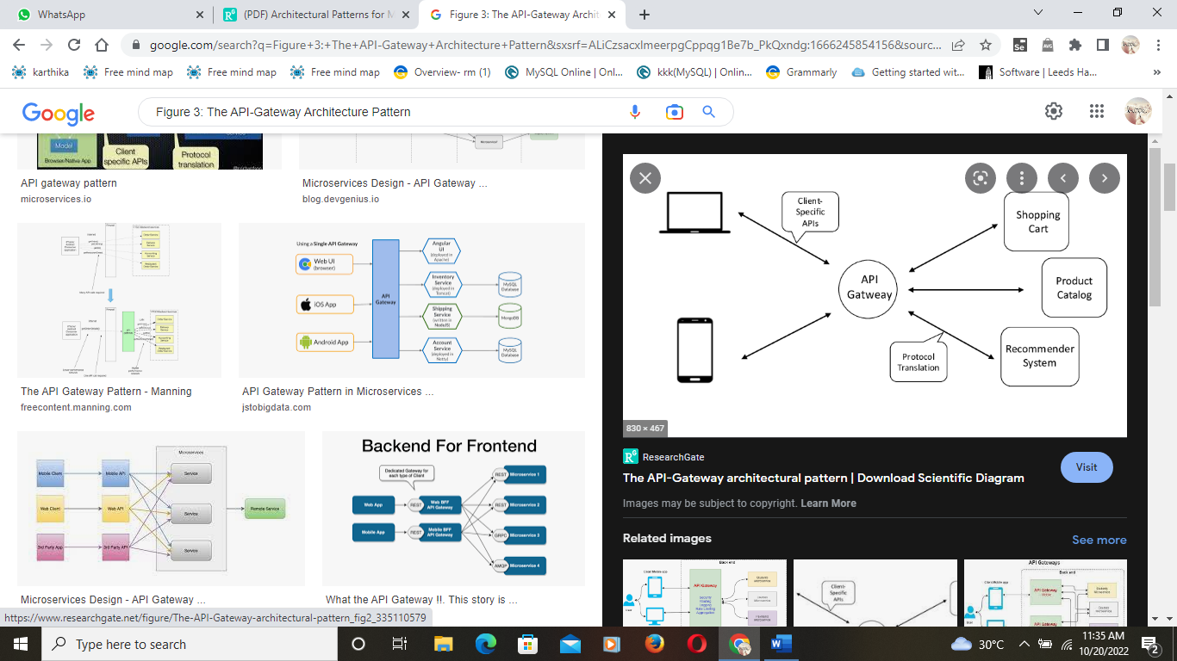

**API gateway structure schemes** [7]

The above figure indicates the API gateway progress that was evolved through the author with enhancement of the different concepts and access.

# Methodology

The proposed study is been initiated with the qualitative methods for the proposing of software architecture for the future IoT development. The qualitative methods seem to make the analysis from the previous literatures, this method helps on accessing the data and some techniques from the present which is highly available through the various articles. Some of these observed data has been initiated on this proposed work, and various patterns and styles over the software architecture is been implemented. This method has engaged with the collections of data and concepts of the technologies and deployments been implemented. As well the microservice architectural pattern is the major and main method observed for the proposed work and some of its benefits and usages have been deployed towards the development of the IoT technology.

# Architectural style pattern on framework

The proposed work tends to initiate the software architecture for the future development of IoT. Hence, this work is been created with the microservice architecture for the effective development of IoT technology.

**Microservice architectural pattern**

There are many approaches and styles that builds and brings the IoT solution in effective manner, and the microservice structure is been proposed on this paper for the effective development of IoT, this pattern seems to occupy the user interface systems, it is been well acknowledged through the business logic criteria, and database been combined through the single programs with the single server on future development of the IoT. This microservice approach seems to work with different cases and benefits, it is been highly proven to be insufficient would be occurred with the complexity of the software systems that is whole applied over the functional IoT solution. This approach helps to split the IoT application and to develop the granular functional services with the service running with the process and communicating with the APIs. As well in future, this approach is highly helpful on raising the flexibility, code functionalities and the microservice architectural styles and development. And largely the microservice collections will help on merging the high macro services, in letting the highest ability to update with quick code of single functions in all over services with end-user application. And the independent deployment of the microservice helps on extending the IoT application functionality with adding of the more service timing and enhancement. The below figure would be indicating the microservice architecture with the designed and structured pattern.

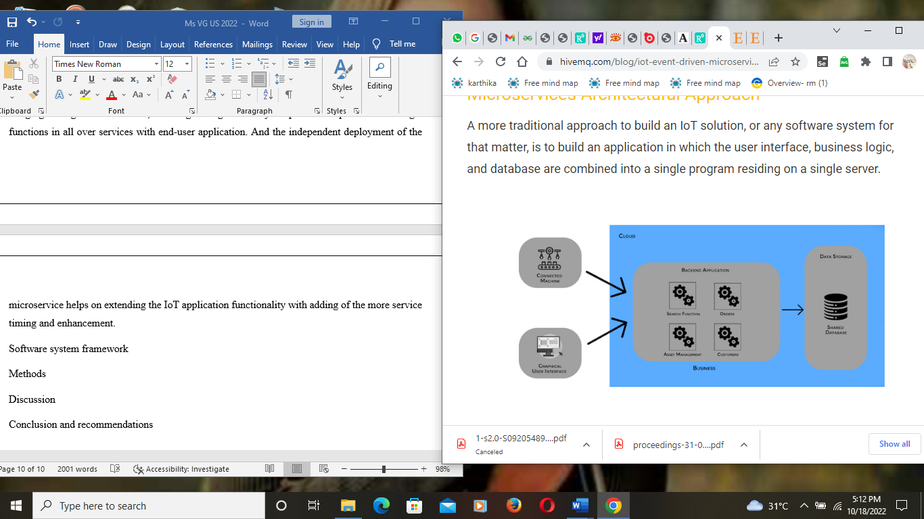

**Microservice structure** [8]

The microservice seems to indicate the solutions and security in the forms of the various sections and some are;

**Flexibility and agile based development** – application of the microservice systems, that are managed through the IoT networks and devices seems to ensure the business logic functions, with enhancement of the flexibility and deployment control forms. As the microservice seems to be the loosely coupled software entities, the developers would tend to make the prediction with the savings of IoT network computing resources.

**Portability and resource-efficiency** – this microservice seems to show and scale the autonomous data workload with the results of the IoT system resource enhancement. And the microservice seems to deploy it with the off-premises, and it tends to meet with better performance with optimized IoT system operations.

**Effective update and resilient operations** – the microservice are also enabled to provide the best updates with the mitigation of the risks and the compose of the IoT systems will be effectively composed through the single server machines.

# Microservices solution for IoT application security

Microservices seems to be the various different code design pattern event-driven pattern, and this is enhanced within the development of the pattern and many more additional. The microservice pattern accessed the name with different features and the architecture seems to enhanced the various characteristics. The IoT is been developed through various forms and the division of the applications are emerged largely without proper security. In which the microservice would be tend to induce the solution with security enhancement, initiation of the security protocols is been indicated with the different formation. In means of addressing the security issues, the framework incorporates with the security microservices, with the initiation of role management, access control, identity governance and authorization. And these frameworks are initiated in the forms of various encryption methods and it would be easily scaled, integrated with the third-party applications using the message-based and it initiates the discovery related mechanisms. As well the implementation of the attribute-based control access, and application-based access control would be effectively initiated with high benefits.

# Needs of microservices approaches

Independent components would be produced for the future IoT development, every service would be deployed, updated and developed independently which lets the parallel development and it saves many times for the organization cost. As well the application scaling has been raised to separate the services, it will be needed of resources for the specific service which would scale the particular times and impact of cost savings have acquired. It raises the fault isolation, once the single service lags, it would not affect any other entire application. As well the better management of the isolation will be provided. As well it is easy to understand the progresses, since the services are divided with less components the complexity of the application is decreased which helps the management with best accessible.

# Future directions and solution

**Blockchain as a server** – this is effective technology that could be used on the future for development of IoT as the blockchain technology would be progressing as the third party for the secure of heterogeneous ecosystems with microservices based IoT applications.

**Trust management** – the IoT applications would be behaved with the effective trust forms of data as the latest cloud system would be inducing the service providers for developing the trust between the owners and users [9]. In means of addressing the trust issues, proxy encryption schemes would be incorporated through the smart contracts on runtime with effective initiation and designed progress.

# Conclusion and recommendations

Hence, in latest years the organization, governments and some of the users have been raised with initiation of the smart technology which attracts the customers through many benefits. And the IoT technology development would be highly effective and safe for the apply, in means of the IoT and large adoption many vital fields been occupied and emerged with the application access. Hence, in this research, I have implemented the software architecture with large benefits and features for the development of future IoT technology. On which the IoT technology would be accessing the best on its progresses and security maintenance for the further enhancement. This research seems to review different forms of the study on the enhancement of minimizing of the security challenges. Different problems in the present IoT technologies were found and implemented, on which the various solutions were also implemented further. And various patterns for the microservices based systems been accessed from the present initiation. Which have tended to associate the patterns with some particular application settings and further monolithic-to-microservices been emerged from the microservice migration which was been found from the different analysis and enhancement. The put of the various similar research were enhanced within the study for the IoT technology development. Different methods, research types and some of the observed design was accessed and initiated. As well the framework enhancement, and some of the approaches were initiated within the development. As the recommendation it is necessary to initiate the various framework and approaches for the development of IoT technology on the future enhancement. As well, implementation of AI and blockchain concepts would be highly preferable which would keep up with latest trending ideas.

# References

|  |  |
| --- | --- |
| [1] | M. Akour, S. Aldiabat, H. Alsghaier and K. Alkhateeb, "Software Architecture Understandability of Open Source Applications," *International Journal of Computer Science and Information Security (IJCSIS),* vol. 14, no. 10, pp. 65-78, 2016. |
| [2] | A. Razzaq, "A Systematic Review on Software Architectures for IoT Systems and Future Direction to the Adoption of Microservices Architecture," *SN Computer Science,* vol. 1, no. 350, pp. 1-30, 2020. |
| [3] | E. Croes, "Software Architectural Styles in the Internet of Things," *Thesis ,* pp. 1-172, 2015. |
| [4] | I. Dodig, D. Cafuta and T. K. a. I. Cesar, "A Novel Software Architecture Solution with a Focus on Long-Term IoT Device Security Support," *Applied science ,* vol. 1, pp. 1-24, 2021. |
| [5] | M. Jaiswal, "Software Architecture and Software Design," *SSRN Electronic Journal,* vol. 6, no. 11, pp. 2452-2454, 2019. |
| [6] | N.-C. Gaitan, V. G. Gaitan and I. Ungurean, "A Survey on the Internet of Things Software Arhitecture," *International Journal of Advanced Computer Science and Applications ,* vol. 6, no. 12, pp. 140-143, 2015. |
| [7] | D. Taibi and V. Lenarduzzi, "Architectural Patterns for Microservices: A Systematic Mapping Study," *8th International Conference on Cloud Computing and Services Science,* pp. 1-20, 2018. |
| [8] | K. Manditereza, "Event Driven Microservices Architecture for IoT Solutions Using MQTT," HiveMq, 14 December 2021. [Online]. Available: https://www.hivemq.com/blog/iot-event-driven-microservices-architecture-mqtt/. [Accessed 2021]. |
| [9] | M. Drissa and D. Hasanb, "Microservices in IoT Security: Current Solutions, Research Challenges, and Future Directions," *Procedia Computer Science,* vol. 192, p. 2385–2395, 2021. |